Jan. 24th, 2019
Tokyo Rope International Inc.

Completion of AASHTO CFRP Guide Specification

We would like to inform you that the American Association of State Highway and Transportation Officials (AASHTO) has approved and formally documented the Design of Concrete Bridge Beams Prestressed with Carbon Fiber-Reinforced Polymer (CFRP) Systems. The completion of these design guidelines enables the design of bridge beams using CFCC® in all states nationwide, and is expected to expand sales of CFCC®.

※The documented Design Guide Specification can be purchased at AASHTO's Webstore (https://store.transportation.org/). (Below is the cover, beams using our CFCC as tension materials are shown.)

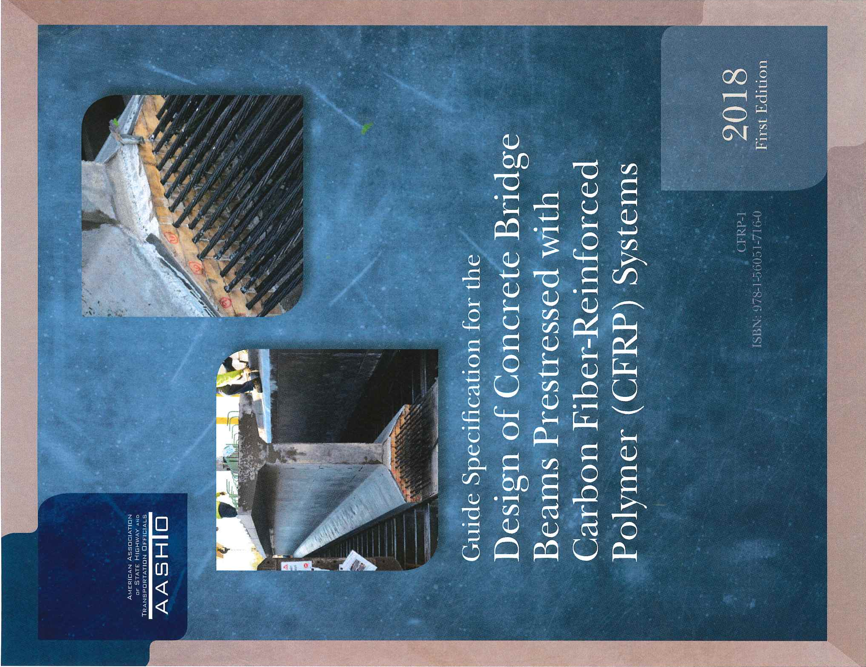
[Our CFCC Civil Engineering Business]
CFCC® (Carbon-Fiber Composite Cables), which plays significant roles in our growth strategies, is divided into two major business areas: power transmission lines and civil engineering. In the civil engineering business, it is mainly used as tension materials for concrete bridge beams. CFCC® has the same strength as conventional steel stranded wires and corrosion free characteristic, thus can reduce life cycle costs by extending the life of bridges.
The main target area for civil engineering projects is North America. In the United States, about 600,000 bridges have been constructed, more than 200,000 of which have been constructed 50 years ago, and 25% (150,000) of all bridges are said to have structural or be functionally obsolete. In particular, in areas such as northern part of the U.S. where large amounts of snow-melting agents are used, and coastal areas exposed to sea water or sea winds, salt damage produces corrosion of steel strands inside bridges, which causes deterioration of bridge beams. We are engaged in sales activities to promote CFCC® as prestressing strands for bridge replacement in these regions. We already have successful installation records in several U.S. states such as Michigan, Ohio, Virginia, North Carolina, and Florida. In Michigan, a design guideline for bridge beams has been developed under the leadership of Dr. Nabil Grace of Lawrence Technological University and has already begun to be put into practical use by the State Transportation Bureau. In addition to concrete bridge beam tensioning materials, concrete piles are also used in Virginia and Florida. Demand is expected to grow in the future.
In 2016, we established a plant in Michigan, the United States, to respond to local production and consumption needs.

